
Child Safeguarding Policy

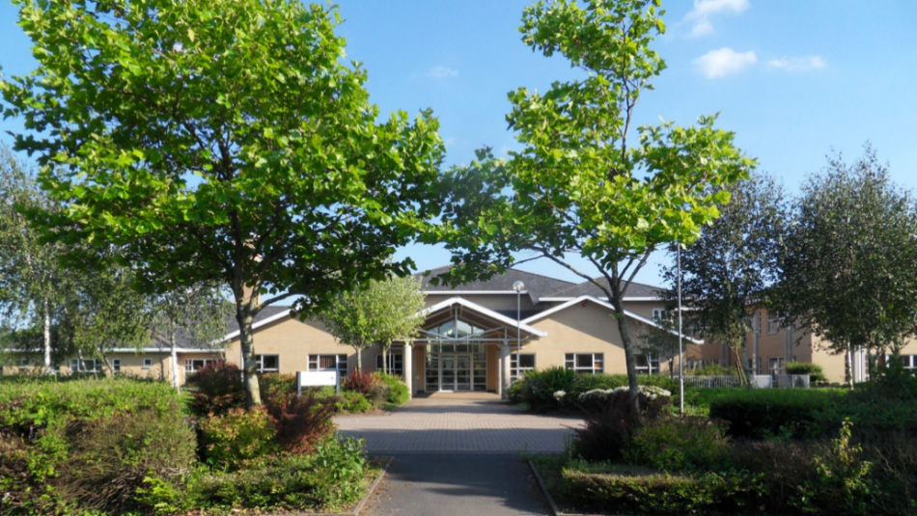

Policy approved / agreed: | June 2021
Date of previous review: | September 2024
Date of next review: | September 2025

Bro Myrddin Welsh-medium Comprehensive School Child Protection Policy

Introduction

1.1 Bro Myrddin Welsh-medium Comprehensive School fully acknowledges the contribution it makes to protecting children.

There are three main elements in our policy:
- prevention through education and pastoral support offered to pupils and the use of preventive services such as the Family Around the School Team
- procedures for identifying cases or suspicions of abuse and reporting them. Due to our daily contact with children, school staff are well placed to notice any external signs of abuse, and
- supporting pupils who are in need or who may have been abused.

1.2 Our policy applies to all staff, governors, and volunteers working in the school. Learning support assistants, midday supervisors, carers, secretaries as well as teachers may be the first point of disclosure for a child.
Our school will review the policy annually and is committed to following any new guidelines issued by Carmarthenshire County Council or the Welsh Government.
1.3 The Designated Senior Persons for Child Protection in this school are Dr Llinos Jones, Mr Steffan Davies, and Mr Jonathan Thomas as Deputy Person.

Prevention
2.1 We recognize that high self-esteem, confidence, supportive friends, and good lines of communication between pupils and a trusted adult help to safeguard pupils.
Therefore, the school will:
a) establish and maintain an ethos where children feel safe and are encouraged to speak out and where we listen to them;
b) ensure children know that there are adults in school they can approach if they are worried or in trouble;
- Include activities and opportunities for relationships and sexuality education in the curriculum, which nurture the skills children need to keep safe from abuse and to know who to turn to for help
- Include materials to help children develop realistic attitudes towards adult life responsibilities in the curriculum, especially regarding childcare and parenting skills
- Foster relationships with other agencies and ensure early and appropriate referrals for support and intervention before risks escalate
- Adopt a whole-school (setting) approach to welfare which incorporates safeguarding and preventative measures to support children and families

Procedures
The following should be followed if there is a case of disclosure/concern about child protection
3.1 We will follow the All-Wales Child Protection Procedures confirmed by the Local Child Protection Board.
3.2 The school will:
a) ensure it has a senior designated staff member who has received appropriate training – 3 members of the Senior Leadership Team – Dr Llinos Jones, Mr Steffan Davies, and Mr Jonathan Thomas.
b) acknowledge the role of the designated persons and arrange support and training for all staff.
c) ensure every member of staff and every governor knows:
- the names of the designated persons and their roles, the local authority contact point, and the designated safeguarding governor
- that they have individual responsibility for reporting to social services or the police about children at risk and safeguarding concerns, within agreed timescales with the Regional Safeguarding Board, including how to handle concerns if the Senior Designated Person is unavailable
d) ensure staff are alert to signs of abuse and know how to respond to pupils who may disclose abuse;
e) ensure staff registered with the Education Workforce Council (EWC) are aware of the Code of Conduct and Professional Practice and the expectation to prioritize the safety and welfare of learners in their care;
f) ensure parents understand the school's and staff's responsibility to safeguard children through the school prospectus;
g) provide training for all staff so they know:
(i) their personal responsibilities;
(ii) the local agreed procedures and their duty to respond;
(iii) how to support a child disclosing abuse or neglect;
(iv) understand the role that online behaviour may have in any of the above;
h) notify the local social services team if:
- a child on the child protection register is excluded temporarily or permanently; and
- a child on the child protection register is absent from school without explanation for more than two days (or one day following a weekend);
i) work to develop effective links with relevant agencies and cooperate as needed with their child protection investigations, including attending initial reviews, core groups, safeguarding conferences, and submitting written reports;
j) keep written records of child welfare concerns (noting date, event, and actions taken), even if the matter is not immediately referred to social services;
k) ensure all records are kept securely and under lock and key;
l) adhere to Welsh Government procedures on discipline and dismissal of school staff: Revised guidance for governing bodies;
m) ensure recruitment and selection procedures follow Welsh Government Keeping Learners Safe guidance;
n) appoint a safeguarding governor to oversee child protection policy and practice in the school: Mrs Angharad Jones Leefe.

Guidance to Supplement the Child Protection Policy

Dealing with a Disclosure Made by a Child
Listen
Listen carefully to what is said without showing shock or disbelief.
- Accept what is said. The child making the disclosure may be known to you as someone who does not always tell the truth. However, do not let your prior knowledge of this person cause you to prejudice or discredit their claim.
- Do not try to investigate the allegation. Your duty is to listen to what is said and pass that information on.
Comfort
- Provide sufficient comfort to the child. Always be honest and do not make promises you cannot keep, e.g., “I’ll stay with you,” or, “Everything will be alright now.”
- Alleviate any guilt if the pupil refers to it. For example, you might say: “It’s not your fault. This is not your fault.”
- Do not promise confidentiality. You have a duty to pass on the information, and the child needs to be aware of this.
Respond
- You may ask questions, and sometimes you will need to. However, this is not an opportunity to interrogate the child or ask detailed questions over a long period. Only the obvious points of the allegation need to be known. Any questions must be open-ended and not leading. For example, A-Afford me, E-Explain, D-Describe.
- Do not criticize the alleged perpetrator because the child may still have a positive emotional attachment to this person.
- Do not ask the child to repeat the allegation to another member of staff. If asked to repeat it, the child may feel not believed and/or their recollection of what happened may change.
Record
- Take notes as soon as it is practical to do so. Record the exact words used by the child – do not translate them into adult language or try to make sense of the structure of what was said. Do not be overwhelmed by any abusive language or words used to describe the abuse.
- Note the time and date on your notes and do not destroy them in case they are required by a court.
- Where possible, note the location of any bruising or injury but do not ask the child to remove any clothing for this purpose.
- Record statements and observable things, rather than your interpretations or assumptions.
Final Steps
- After following the above guidelines, pass the information immediately to the Designated Senior Person or the individual responsible for Child Protection. They will then have several possible options, including contacting the Children’s Services Department to seek advice on what should happen next.
Confidentiality
Regarding child protection, confidentiality is not absolute and can be breached where it is in the best interests of the child and the wider public good. If professionals believe disclosure is necessary to protect the child or other children from risk of serious harm, confidentiality can be broken. Staff should refer to the Local Authority’s guidelines “Guidance to Schools: Consent for Referrals to the Team Around the Family/Children’s Services.”
Where those in educational settings consider it necessary to share confidential information with children’s social services or the police:
- They should seek to support the child;
- They may discuss the case anonymously at first with other relevant colleagues, such as the Designated Safeguarding Person or another colleague with suitable safeguarding competence or with the children’s social services department;
- The child should be told about the professional’s need to share confidential information unless doing so would place the child at further risk;
- Any decision to share or not to share information must be appropriately recorded.
Decisions in this area must be made by, or with advice from, people with appropriate safeguarding competence, such as designated professionals named.

Managing Allegations Against Adults Working with Children
If an allegation of child abuse is made against a member of staff, the person receiving the allegation must immediately pass the details of the concern to the Headteacher or, in their absence, a staff member with Headteacher responsibilities. The Headteacher will then contact the Chair of Governors and the Central Referral Team to discuss next steps according to local arrangements. Staff should not speak to the individual against whom the allegation has been made or share information with anyone else.
If a possible child abuse allegation is made against the Headteacher, the staff member receiving the allegation must contact the Chair of Governors. The Chair of Governors will then contact the Central Referral Team to discuss next steps in line with local arrangements. If the Chair is unavailable, the staff member can seek advice from the Central Referral Team.

Abuse of a Position of Trust
Welsh Government guidance (“Keeping Learners Safe” 2020) states that all Education staff must know that inappropriate behavior with or towards children is unacceptable. Under the Sexual Offences Act 2003, it is a criminal offence for a person over 18 (e.g., teacher, youth worker) to have a sexual relationship with a child under 18 where that person is in a position of trust with regard to that child, even if the relationship is consensual. This applies when the child is in full-time education and the person works at the same establishment, even if not teaching the child.

Supporting the Pupil at Risk
Child abuse is devastating to the child and can also cause distress and anxiety for staff involved. We recognize that this can have a significant impact on children at risk, suffering abuse, or witnessing violence. The school may be the only stable, safe, and reliable element in the lives of children at risk. However, their behavior at school may be challenging and provocative or possibly withdrawn. The school will strive to support the pupil through:
- Including a curriculum that encourages self-esteem and self-motivation;
- A school/college ethos which:
  - promotes a positive, supportive, and safe environment;
  - gives learners a sense of being valued (see Section 2 on Prevention);
- The school behavior policy aims to support vulnerable pupils at school. All staff will agree on a consistent approach focusing on the behavioral outcomes of the child but without harming the individual’s self-worth. The school will try to ensure the learner knows that some types of behavior are unacceptable but that they are valued and will not be blamed for any abuse that has occurred.
- Liaise with other agencies supporting the learner such as local authority officers – for example, the educational psychology service, behaviour support services, or the Safeguarding and School Attendance Team – children and young people’s mental health services, and advocacy services; keep records and notify the local authority as soon as any concerns arise again.
- Take every suspicion and disclosure seriously
- Appoint a contact person who will notify all parties and act as a central point of contact. When a staff member is the subject of an allegation made by a pupil, separate contact persons will be appointed to avoid any conflict of interest.
- Respond sympathetically to any requests from pupils or staff for time off to deal with trauma or anxiety.
- Maintain confidentiality and share information on a ‘need to know’ basis only with relevant individuals and agencies.
- Store records securely.
- Provide details of helplines, counselling, or other external support routes; fully cooperate with relevant statutory agencies, including working with the Police and children’s services in accordance with the Operation Encompass and Operation Endeavour protocols (see below).
- When a learner on the child protection register leaves, we will immediately transfer information to the new provider and notify social services.

OPERATION ENCOMPASS
The school participates in Operation Encompass and Operation Endeavour.
- Operation Encompass was created to support children experiencing domestic abuse by sharing timely information between the police and schools. The purpose of Operation Encompass is to enable schools to provide support to children suffering domestic abuse. Through Operation Encompass, schools can help children understand what is happening at home and the best ways to protect themselves physically and emotionally. The information the school receives also enables them to prepare for the child at school and ensure they have the necessary support.
- The purpose of Operation Endeavour is to protect and support children and young people who have been reported as missing from their home. It is believed that about 25% of children and young people who go missing are at risk of serious harm. There are particular concerns about the links between children running away and risks of sexual exploitation. Operation Endeavour aims to ensure that a Designated Safeguarding Person (DSP) is identified in schools and that he/she is appropriately trained. They should be informed of the incidents at the earliest opportunity to provide timely, tailored support to children and young people at the start of and during the school day.
- Anti-bullying
Our anti-bullying policy is detailed in a separate document and is reviewed annually by the governing body.
- Use of physical intervention
Our policy on physical intervention (a separate document) is reviewed annually by the governing body and is consistent with Welsh Government guidance on Safe and Effective Intervention – the use of reasonable force and searching for weapons
https://llyw.cymru/sites/default/files/publications/2018-03/ymyriad-diogel-ac-effeithiol-defnyddio-grym-rhesymol-a-chwilio-am-arfau.pdf
- Children with additional learning needs
We acknowledge, statistically, that children with additional learning needs are most at risk of abuse. Staff working with children with additional needs (e.g., severe and multiple disabilities, sensory impairments, or emotional and behavioural difficulties) need to be particularly sensitive to signs of abuse.
- Review
This policy is reviewed and approved annually at a full governing body meeting, at least once a year, and recorded in the minutes. In preparation for this review, the Senior Designated Safeguarding Person may provide the Governing Body with information on the following:
- Changes to child protection procedures;
- Training undertaken by all staff and governors in the previous 12 months;
- The number of child protection-related incidents raised in the school during the previous 12 months (without details or names);
- Where and how safeguarding and child protection appear in the curriculum
- Lessons learned from cases.

