

Policy approved / Policy agreed: | 31st of March 2023
Date of last review: | 31st of March 2023
Date of next review: | March 2025
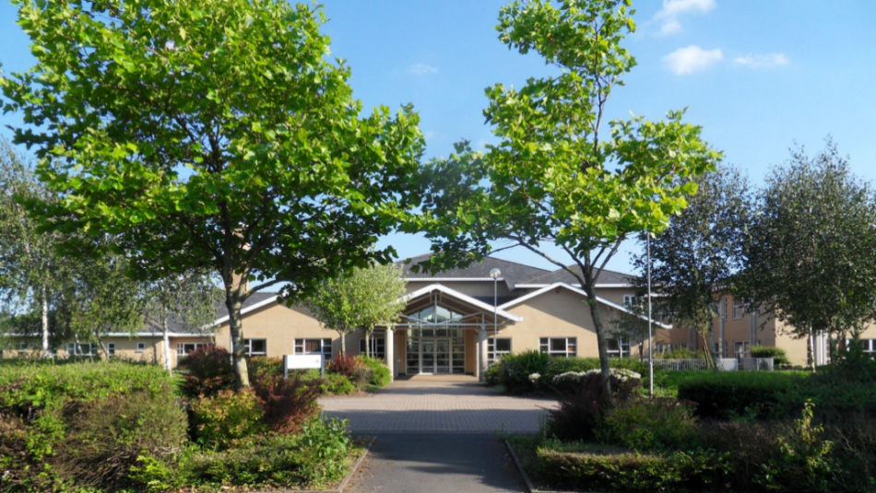
Complaints Procedure
Complaints Procedure
- Introduction

1.1 Ysgol Gyfun Gymraeg Bro Myrddin is committed to dealing effectively with complaints. We aim to clarify any issues about which you are not sure. If possible, we will put right any mistakes we have made, and we will apologise. We aim to learn from mistakes and use that experience to improve what we do.

1.2 We have a zero-tolerance approach to all forms of bullying and harassment and promote respectful relationships between learners, parents, staff, and governors.

1.3 Our definition of a complaint is ‘an expression of dissatisfaction in relation to the school, a member of its staff or the governing body that requires a response from the school.’

1.4 This complaints procedure supports our commitment and is a way of ensuring that anyone with an interest in the school can raise a concern, with confidence that it will be heard and, if well-founded, addressed in an appropriate and timely fashion.

2 When to use this procedure

2.1 When you have a concern or make a complaint, we will usually respond in the way we explain below. Sometimes you might be concerned about matters that are not decided by the school, in which case we will tell you who to complain to. At other times you may be concerned about matters that are handled by other procedures, in which case we will explain to you how your concern will be dealt with.

2.2 If your concern or complaint is about another body as well as the school (for example the local authority) we will work with them to decide how to handle your concern.

3 Have you asked us yet?

3.1 If you are approaching us for the first time you should give us a chance to respond. If you are not happy with our response, then you may make your complaint using the procedure we describe below. Most concerns can be settled quickly just by speaking to the relevant person in school, without the need to use a formal procedure.

4 What we expect from you

4.1 We believe that all complainants have a right to be heard, understood, and respected. School staff and governors have the same right. We expect you to be polite and courteous. We will not tolerate aggressive, abusive, or unreasonable behaviour.

4.2 Nor will we tolerate unreasonable demands, unreasonable persistence nor vexatious complaining. We have a separate policy to manage situations where we find that someone’s actions are unacceptable.

5 Our approach to answering your concern or complaint

5.1 We will consider your concerns and complaints in an open and fair way.

5.2 At all times, the school will respect the rights and feelings of those involved and make every effort to protect confidential information.

5.3 Timescales for dealing with your concerns or complaints may need to be extended and we will notify you. We may ask for advice from the local authority or diocesan authority where appropriate. Some types of concern or complaint may raise issues that have to be dealt with in another way (other than this complaints policy), in which case we will explain why, and tell you what steps will be taken.

5.4 Complaints that are made anonymously will be recorded but investigation will be at the discretion of the school depending on the nature of the complaint.

6 Answering your concern or complaint

6.1 There are up to three Stages: A, B and C. Most complaints can be resolved at Stages A or B. You can bring a relative or companion to support you at any time during the process, but you will be expected to speak for yourself, unless you require special assistance. We also recognise that when the complainant is a pupil it is reasonable for the companion to speak on their behalf and/or to advise the pupil.

6.2 As far as possible, your concern or complaint will be dealt with on a confidential basis. However, there could be occasions when the person dealing with your concern or complaint will need to consider whether anyone else within the school needs to know about your concern or complaint, so as to address it appropriately.

6.3 If you are a pupil under 16 and wish to raise a concern or bring a complaint, we will ask for your permission before we involve your parent(s) or carer(s). If you are a pupil under 16 and are involved in a complaint in any other way, we may ask your parent(s) or carer(s) to become involved and attend any discussion or interview with you.

Stage A

6.4 If you have a concern, you can often resolve it quickly by talking to a teacher or the Deputy Headteacher. You should raise your concern as soon as you can; normally we would expect you to raise your issue within 10 school days of any incident.

6.5 The longer you leave it the harder it might be for those involved to deal with it effectively.

6.6 If you are a pupil, you can raise your concerns with your school council representative, form tutor or a teacher chosen to deal with pupil. This will not stop you, at a later date, from raising a complaint if you feel that the issue(s) you have raised have not been dealt with properly.

6.7 We will try to let you know what we have done or are doing about your concern normally within 10 school days, but if this is not possible, we will talk to you and agree a revised timescale with you.

6.8 The person overseeing your concern or complaint will keep you informed of the progress being made. This person will also keep a log of the concern for future reference.

Stage B

6.9 In most cases, we would expect that your concern is resolved informally. If you feel that your initial concern has not been dealt with appropriately you should put your complaint in writing to the headteacher.

6.10 We would expect you to aim to do this within five school days of receiving a response to your concern as it is in everyone’s interest to resolve a complaint as soon as possible. The form at Appendix A you may find useful. If you are a pupil we will explain the form to you, help you complete it and give you a copy.

6.11 If your complaint is about the headteacher, you should put your complaint in writing to the chair of governors, addressed to the school, to ask for your complaint to be investigated.

6.12 In all cases, the Deputy Headteacher can support you to put your complaint in writing if necessary.

6.13 If you are involved in any way with a complaint, the Deputy Headteacher will explain what will happen and the support that is available to you.

6.14 The school’s Deputy Headteacher invite you to discuss your complaint at a meeting. Timescales for dealing with your complaint will be agreed with you. We will aim to have a meeting with you and to explain what will happen, normally within 10 school days of receiving your letter. The school’s Deputy Headteacher will complete the investigation and will let you know the outcome in writing within 10 school days of completion.

Stage C

6.15 If you still feel that your complaint has not been dealt with fairly, you should write, through the school’s address, to the chair of governors setting out your reasons for asking the governing body’s complaints committee to consider your complaint. You do not have to write down details of your whole complaint again.

6.16 If you need assistance instead of sending a letter or e-mail, you can talk to the chair of governors or the Deputy Headteacher who will write down what is discussed and what, in your own words, would resolve the problem and then be asked to sign them as a true record of what was said. We would normally expect you to do this within five school days of receiving the school’s response. We will let you know how the complaint will be dealt with and will send a letter to confirm this. The complaints committee will normally have a meeting with you within 15 school days of receiving your letter.

6.17 The letter will also tell you when all the documentation to be considered by the complaints committee must be received. Everyone involved will see the documentation before the meeting, while ensuring that people’s rights to privacy of information are protected. The letter will also record what we have agreed with you about when and where the meeting will take place and what will happen. The timescale may need to be changed, to allow for the availability of people, the gathering of information or seeking advice. In this case, the person dealing with the complaint will agree a new meeting date with you.

6.18 Normally, in order to deal with the complaint as quickly as possible, the complaints committee will not reschedule the meeting more than once. If you ask to reschedule the meeting more than once, the committee may think it reasonable to make a decision on the complaint in your absence to avoid unnecessary delays.

6.19 We aim to write to you within 10 school days of the meeting explaining the outcome of the governing body’s complaints committee’s consideration.

6.20 The governing body’s complaints committee is the final arbiter of complaints.

7 Special circumstances

7.1 Where a complaint is made about any of the following the complaints procedure will be applied differently.

- A governor or group of governors:
- The concern or complaint will be referred to the chair of governors for investigation.
- The chair may alternatively delegate the matter to another governor for investigation.
- Stage B onwards of the complaints procedure will apply.

- The chair of governors or headteacher and chair of governors:
- The vice chair of governors will be informed and will investigate it or may delegate it to another governor.
- Stage B onwards of the complaints procedure will apply.

- Both the chair of governors and vice chair of governors:
- The complaint will be referred to the clerk to the governing body who will inform the chair of the complaints committee.
- Stage C of the complaints procedure will then apply.

- The whole governing body:
- The complaint will be referred to the clerk to the governing body who will inform the headteacher, chair of governors, local authority and, where appropriate, the diocesan authority.
- The authorities will agree arrangements with the governing body for independent investigation and consideration of the complaint.

- The headteacher:
- The concern or complaint will be referred to the chair of governors who will undertake the investigation or may delegate it to another governor.
- Stage B onwards of the complaints procedure will apply.

8 Our commitment to you

8.1 In all cases the school and governing body will ensure that complaints are dealt with in an unbiased, open, and fair way.

8.2 We will take your concerns and complaints seriously and, where we have made mistakes, will try to learn from them.

8.3 If you need help to make your concerns known, we will try and assist you.

8.4 If you are a young person and need extra assistance you may want to contact MEIC which is a national advocacy and advice helpline for children and young people. Advice and support can be accessed from the Children’s Commissioner for Wales.

Appendix A: Complaints form
Usually, the individual who had the problem should complete this form. If you make a complaint on behalf of someone else, you should also complete Section B. Please note, before we go on to deal with the complaint that we need to satisfy ourselves that you have the authority to act on behalf of the individual in question. If you are a pupil, the school will help you complete this form, the school will explain it to you and give you a copy once it has been completed.

Your details

Surname
First name(s)
Title: Mr/Mrs/Ms/other
Address and post code
Daytime phone number
Mobile phone number
Email address

What is the best way for us to contact you?

If you are making a complaint on behalf of anyone else, note his/her details

His/her name in full
Address and post code
What is your relation to him/her?
Why are you making this complaint on his/her behalf?

Regarding your complaint (you can continue your answers on separate pages if needed)

C.1 | The name of the school you’re complaining about.
C.2 | In your opinion, what did they do wrong or what they didn’t do.
C.3 | Describe the effect this has had on you.
C.4 | When did you become aware of the problem for the first time?
C.5 | If there are more than three months since you became aware of the problem for the first time, state the reason why you haven’t complained before now.
C.6 | In your opinion, what should be done to solve the situation?
C.7 | Have you already notified a member of staff about your complaint? If you have, give brief details regarding how and when you did that.
Complainant’s signature: |  | Date:
Signature if you are making a complaint on behalf of someone else;  Signature: |  | Date:
This form and any other documents to support your complaint should be sent to:
The deputy head, Ysgol Gyfun Gymraeg Bro Myrddin, Croesyceiliog, Carmarthen, SA32 8DN.
Appendage A: A summary of how to deal with concerns or complaints
This procedure is followed if a concern or complaint about the school is presented,
as long as the concern or complaint is not relevant to other statutory procedures.

Matter is solved
Step A: Express your concern to the teacher or Deputy Head within 10 school days

Write to the headteacher or the Deputy Head within five school days
Matter not solved

Step B: The head* or the deputy head will investigate your complaint and meet with you. You will receive a letter noting the result within 10 school days of the date of receiving the letter

Matter is solved

Matter not solved
Step C: write to the Chair of the Governors** within
five school days

The complaint will be heard by the Governing Body’s complaints committee within 15 school days to the days of receiving the letter

Matter is solved
You will be notified of the result within 10 school days

*If the complaint is to do with the head, you should write to the chairperson of the governing body.
** If the complaint is to do with the governors’ chairperson; you should write to the vice-chairperson.
The timetables shown are targets and they are flexible; it is of benefit to everyone that the complaint is solved as soon as possible.
The school will work with you to ensure that the time allocated to deal with a matter that causes concern to you or your complaint is reasonable and it helps to get an answer to the problem.

