
Pupil Mobile Phone
Policy

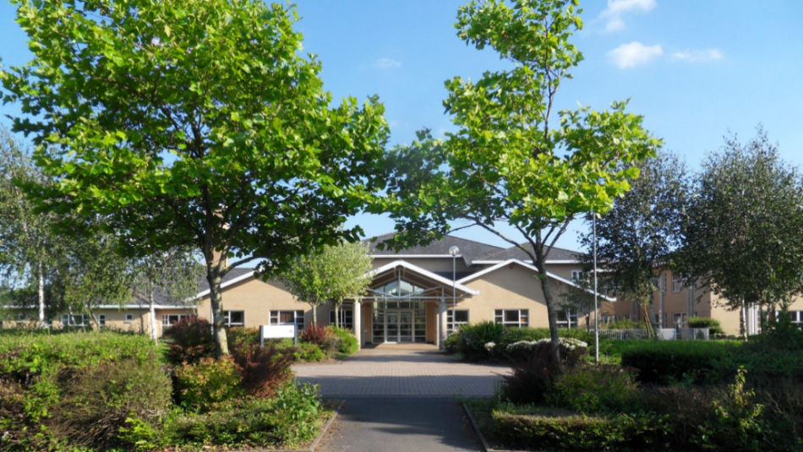

Policy approved / agreed: | 26th of June 2025
Date of review: | 26th of June 2025
Next review: | June 2026

Mobile Phones for Pupils

At Ysgol Gyfun Gymraeg Bro Myrddin, we recognize the usefulness of mobile phones in certain situations. We appreciate how important it is for parents to be able to keep in touch with their children via mobile phones outside school hours. However, both locally and nationally, there is increasing evidence of the misuse of mobile phones, including online bullying, inappropriate use of images, and other types of harassment. We also recognize that pupils spending so much time in front of screens is a growing concern because of the negative impact on learning and well-being. Mobile phones can affect their education by distracting learners during the school day and preventing them from strengthening real-life friendships. By reducing phone use, we aim to remove barriers so that pupils can fully focus in their lessons and spend quality time socializing with each other in their free time. In light of this, our intention is to implement a ban on mobile phones during school hours.

Curriculum and Prevention

The PSHE (Personal, Social, Health and Economic education) and Health and Well-being programs throughout the school seek to address the possible disadvantages of using social media. Work plans provide opportunities for pupils to learn about age-appropriate applications and the potential risks associated with using social media. Alongside the PSHE provision, the school is supported by a police liaison program.

In addition, services are used to communicate messages about safe internet use.

Pupils in Years 7–11 are not permitted to:

- Use mobile phones on the school site. Therefore, mobile phones/devices must be switched off during school hours and handed into the office until the end of the day. This includes using a ‘SMART’ or Apple watch – these are mobile phones for all intents and purposes and will be treated the same way.
- Upon arriving at the school site, phones/devices and headphones must be placed in the office and should not be moved from there unless a member of staff allows it, until they leave the school site at the end of the day.
- If any pupil uses their mobile phone without staff permission during school hours, the phone will be taken by a member of staff and placed in the office.
- Parents, guardians, or an adult extended family member may collect the phone from the main office at any convenient time during the school term.
- If parents wish to contact their child at school, they must use the school’s phone number: 01267 234 829.
- If a pupil needs to contact home during the day, they may go to reception and use the school phone.
- When pupils attend trips or sports activities off-site, they may use their own mobile phones to contact home to arrange safe return home.
- If a pupil decides to bring a mobile phone to school and keep it in their bag, the school accepts no responsibility for loss or damage.
- If a mobile phone is needed for specific medical reasons, this must be agreed with the school in advance.
- The use of headphones or connecting to anything via Bluetooth is not permitted during the school day.

If a pupil refuses to hand over their mobile phone/device to a member of staff, the school will follow the school’s behaviour management procedures.

Cases of cyberbullying will be referred to the Police.
Students in Years 12 and 13 will be able to access their phones only in the Sixth Form area. Apart from this area, the same rules apply.

Breaking the Rules
Any kind of misuse of a mobile phone is treated as a serious breach of the student’s commitment and will be dealt with in accordance with the Behaviour Policy. ‘Misuse’ is at the discretion of the Headteacher and includes:

- Sending inappropriate messages
- Sending inappropriate messages or posts to social networking sites or blogs
- Taking pictures and/or videos at school
- Taking pictures or filming staff or other students without their knowledge or consent
- Taking pictures or filming in toilets, changing rooms, or similar areas
- Bullying, harassing, humiliating, or threatening staff or students using text messages, email, or multimedia
- Using a mobile phone outside school hours to intimidate or upset staff and students will be treated as a breach of these guidelines in the same way as misuse during school hours.
- Intentionally arranging situations where people’s reactions are filmed or photographed to humiliate, embarrass, or frighten by publishing to a wider audience such as Facebook or YouTube
- Bullying through text messages, images, and email
- Posting material on social networking sites without considering the risks to their personal reputation and sometimes with the deliberate intention of harming others
- Making disrespectful comments, misrepresenting events, or making nasty remarks about teachers or other students
- General disruption to learning caused by students accessing phones during lessons
- Students calling parents without permission
- Students calling parents immediately after an incident, which can jeopardize staff’s ability to manage the situation, such as publishing photos of vulnerable students who may be on a child protection plan, placing them at additional risk.

Dealing with breaches of rules

Misuse of mobile phones is dealt with using the same principles outlined in the school’s Behaviour Policy, with responses proportionate to the seriousness of the misuse. Students are aware that serious misuse can lead not only to confiscation of their mobile phone but may also include internal or external exclusion from school. If the offence is serious, it will be reported to the Police.

Sanctions

Students and parents are informed that appropriate action will be taken against those who break the acceptable use guidelines, following the school’s Behaviour Policy. In addition:
- Students and their parents should be very clear that the school has the right to keep their phone if the guidelines are broken.
- If a phone is confiscated, a parent/guardian will need to collect the phone from the school.
- Students should be aware that the police will be informed if there is serious misuse of a mobile phone where criminal activity is suspected.
- If a student commits an act that causes serious disturbance, intimidation, or distress to another student or staff member, the ultimate sanction may be exclusion. The school will consider the impact of the act on the victim when deciding on the sanction.

Confiscation Procedure
If a mobile phone is confiscated, then:

- It will be kept until a parent/guardian personally collects the phone from the school.
- The confiscation will be recorded in the school’s behaviour log for monitoring purposes.
- The school will ensure that confiscated equipment is stored in such a way that it can be returned to the correct person.
- In cases of frequent or serious misuse, the phone will only be returned to a parent/guardian who will be asked to visit the school by appointment to collect it.
- Where a student repeatedly breaks expectations, following a clear warning, the Headteacher may completely ban the student from bringing a mobile phone to school. This may be a fixed-term or permanent ban.
- Where the phone has been used for unacceptable purposes, the Headteacher or designated staff member has the right to view files stored on confiscated devices and, if necessary, seek parents’ cooperation to delete any files clearly breaching these guidelines unless they need to be kept as evidence.
- If needed, evidence of the offence or suspected offence will be retained, ideally by confiscating the device and keeping it securely, or by taking photographs of the screen.
- The school will consider whether to report the incident to the local safeguarding board.
- The designated staff member should monitor repeat offences to see if there is any pattern in the offender or victim that requires further investigation.

Parental support with this is extremely important and very much appreciated. Many studies highlight the negative effects of screen time on the mental health, well-being, and brain development of young people, and we feel it is our duty to take these important steps to support the well-being and learning of every pupil.

Frequently Asked Questions

I need to contact my child during the school day. How can I do that?

We understand that parents may want to contact their child at times during the school day. In such situations, we ask parents to follow our current policy of calling the school office (01267 234 829) and a message will be sent immediately to your child’s pin.

My child needs to contact me (parent) during the school day. How can they do this?

Any pupil who needs to contact home should go to the office. We have the phone number of every parent/guardian on our system, and the pupil can use the phone facilities there.

What if a pupil uses their phone to check their timetable or access Google Classroom?

A copy of their timetable is given to all CA3 and CA4 pupils at the start of the year, and they can keep their copy in their pencil case. Staff also have access to pupils’ timetables, so help is available if needed. Every pupil has access to Chromebooks at school for online work, and all homework tasks are set using Google Classroom, which they can also access from home.

What about ALN (Additional Learning Needs) pupils who use their phone to take photos of notes from the whiteboard or to monitor medical conditions? Are they allowed to use their phones?

Some pupils (see Appendix 3) are allowed to use their phones for educational or medical purposes (e.g., apps monitoring diabetes, translation apps, etc.). However, this use must be agreed with the school either as part of their health care plan or ALN review. Parents/guardians will be informed immediately of any inappropriate use, e.g., playing games or using social media while pretending to use the phone for educational or medical reasons.

My child won’t cope without their device.

Phone addiction is an increasing concern for many of us. There will be times when young people and adults must go without their mobile phone for various reasons, e.g., mobile phones are not allowed in any exam room. We feel it is better to educate and support pupils and young people now before it becomes a more serious problem.

Where can I find support and advice about my child’s use of social media?

Gwent Digital Learning Grid (GDDC) provides excellent advice and resources to support parents. Follow the links below for advice to parents:
https://swgfl.org.uk/resources/online-safety-guidance-for-parents/

Parents and Carers – UK Safer Internet Centre

Inclusive Digital Safety advice for Parents and Carers | Internet Matters

Topic: Online Safety and Social Media | SWGfL

Information, Advice and Support to Keep Children Safe Online (internetmatters.org)

Social Media Checklists | SWGfL

Teens 14+ online safety advice and expert tips | Internet Matters

Help & advice 11-18 year olds | Childnet

Resources for 11-19s - UK Safer Internet Centre Report Harmful Content

Gaming | SWGfL

You can also access support through HWB: https://hwb.gov.wales/keeping-safe-online
Parental support with this is vitally important and greatly appreciated. There are many studies into the negative effects of screen time on young people's mental health, wellbeing and brain development and we feel it is our duty to take these important steps to try to support the wellbeing and learning of all pupils.

Appendix 1

Guidance on Confiscation DfE guide on screening and searching – What the law allows (2023 Updated version)
(N.B. this guidance is currently under review)

“Schools’ general power to discipline, as set out in Section 91 of the Education and Inspections Act 2006,
enables a member of staff to confiscate, retain or dispose of a student’s property as a disciplinary penalty, where reasonable to do so.”
See below for full document
https://www.gov.uk/government/publications/searching-screening-and-confiscation

Appendix 2 – Legal context

Common Offences Related to the Misuse of Mobile Telephones

The key to both offences below is that the message/picture/video is actually SENT. (If it is only stored on a device the offence is not complete.)

- Malicious Communications Act 1988
It is an offence to send an indecent, grossly offensive or threatening letter, electronic communication or other article to another person with the intention that it should cause them distress or anxiety

- Communications Act 2003
Section 127 covers all forms of public communications 127(1) a person is guilty of an offence if they-
- send by means of a public electronic communications network a message or other matter that is grossly offensive or of an indecent, obscene or menacing character; or
- causes any such message or matter to be so sent.

127(2) A person is guilty of an offence if, for the purpose of causing annoyance, inconvenience or needless anxiety to another, they –
- send by means of a public electronic communications network, a message that they know to be false,
- causes such a message to be sent; or
- persistently makes use of a public electronic communications network.

Appendix 3
Police response to an incident in school
Extract from the Home Office guidance on the action police should take if a crime may have occurred in school.

In order to sustain the disciplinary authority of schools, this guidance clarifies the general principles of NCRS as they apply specifically to incidents on school premises. When police have reported to them an incident which took place on school premises, including those witnessed by, or reported directly to, officers working in the school, which they would normally record as a notifiable offence will, in the first instance, invite the victim or the person acting on their behalf to report the matter to the head teacher to be dealt with under normal school discipline procedures. Such reports should be recorded as an incident only, until or unless:-
- they judge it to be a serious incident as defined below; [see full document]
- having brought the matter to the attention of the school in line with good practice (see references to guidance papers below), they receive a formal request from the school to create a crime record; or
- the child, parent or guardian or the child’s representative asks the police to create a crime record.

Appendix 4
Safeguarding concerns which may be raised by mobile phone use in school.

Looked after students
There may be a safeguarding concern if a CLA, who has limited contact, or supervised-only contact with a parent, suddenly acquires a mobile phone as this could have been provided by the parent to maintain contact. This should be discussed with the designated teacher for CLA in school.

Young carers
Some young carers only feel able to attend school because their mobile phone enables easy access with the person they care for and may react strongly to a ban on phones or restrictions on their use. This will need to be treated sensitively by the school.

Child sexual exploitation (CSE)
A feature of some of the recent cases where teenage girls have been groomed for sex has been giving them expensive phones as a gift. The unexpected acquisition of an expensive mobile phone by girls who are unlikely to be able to afford one themselves should trigger a safeguarding concern. The same approach is often used to draw children into selling drugs.

Medical Need
Some learners will be allowed to use their phones for educational or medical purposes (e.g. for apps that monitor diabetes, translation apps etc.). However, this usage has to be agreed with the school either as part of their health care plan or ALN review.

